- Define ellipse
- Identify parts of an ellipse
- Construct an ellipse by the concentric circle method
RATIONALE
Knowledge: Parts of an ellipse, construction (Concentric circle, rectangle Methods)
Skills: Manipulation, Accuracy, Drawing, Demonstration
Values: Appreciation, Curiosity, Application, Logical thinking, Problem solving, Quality work
TEACHING AIDS
……………………………………………………………………………………………………………………………………………

PART | LESSON CONTENT | METHODOLO GY | LEARNER ACTIVITY
introduction | - Recap on the previous lesson | Questions and answers | Provide answers
Development | ELLIPSE  Ellipse is plane figure which is bounded by a curved line is oval or egged shaped  - Longest diameter known as major axis  - Shortest diameter known as minor axis  Construct an ellipse by the concentric circle method. Given the major axis =100, minor axis =76mm.  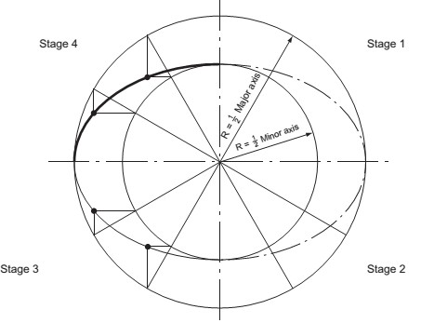 | Questions And Answers  Demonstration  V/E | Taking note of important points  Provide answers
Application | CLASS EXERCISE  Construct an ellipse by the concentric circle method. Given the major axis =80, minor axis =65 mm. | Questions And Answers | Provide answers
Conclusion | - Recap on the main steps and points | V/E

LEARNING OUTCOMES LSBAT
- Construct an ellipse using rectangle method
RATIONALE
Knowledge: Parts of an ellipse, construction (rectangle Methods)
Skills: Manipulation, Accuracy, Drawing, Demonstration
Values: Appreciation, Curiosity, Application, Logical thinking, Problem solving, Quality work
TEACHING AIDS
……………………………………………………………………………………………………………………………………………

PART | LESSON CONTENT | METHODOLO GY | LEARNER ACTIVITY
introduction | - Recap on the previous lesson | Questions and answers | Provide answers
Development | ELLIPSE  Construct an ellipse using rectangle method. Given the major axis  =120, minor axis =60mm.  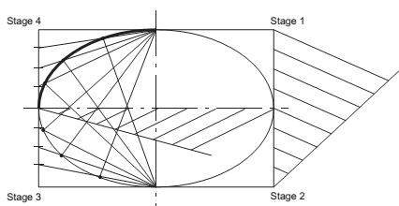  - Stage 1. Draw a rectangle, length and breadth equal to the major and minor axes.  - Stage 2. Divide the two shorter sides of the rectangle into the same even number of equal parts. Divide the major axis into the same number of equal parts.  - Stage 3. From the points where the minor axis crosses the edge of the rectangle, draw intersecting lines  - Stage 4. Draw a neat curve through the intersections. | Questions And Answers  Demonstration  V/E | Taking note of important points  Provide answers
Application | CLASS EXERCISE  Construct an ellipse using rectangle method. Given the major axis  =120, minor axis =40mm. | Questions And Answers | Provide answers
Conclusion | - Recap on the main steps and points | V/E

